

Data Classification Worksheet
Data Categories | Data Items | Sensitivity Label*  High = 5, Low = 1 | Student Information System | Learning Management System | File Management System
Student and Parent Data | Student - Name | 3
 | Student - Address | 4
 | Student - Photos | 4
 | Student - DOB | 4
 | Student - Medical Records | 5
 | Student - Academic Records | 4
 | Parent - Name | 3
 | Parent - Address | 4
 | Parent - Phone Number | 3
 | Parent - Email Address | 3
 | Parent - Bank Account Details | 5
 | Parent - Credit Card Details | 5
Staff data | Staff - Name | 3
 | Staff - Address | 4
 | Staff - DOB | 4
 | Staff - Personal Phone Numbers | 4
 | Staff - Photos | 4
 | Staff - Personal Email Address | 4
 | Staff - License or other Identity Documents | 5
Finance | Invoicing Ledger Data | 4
 | Historic Invoicing Data | 4
 | Bank Details | 5
 | Tax Return Data | 5
 | Vendor/Supplier/Contractor Contact and Bank Details for Payment | 3
HR and Payroll | Staff PII (DOB, Addresses, Copies of Identity Documents) | 5
 | Salary & Payroll Data | 5
 | Staff Tax File Numbers | 5
 | Employee Contracts | 4
 | Police Checks | 5
Marketing | Website Data | 2
 | Marketing Campaign Data | 2
Governance, Risk and Compliance | Board Papers & Minutes | 3
 | Breach Reports | 5
 | Regulatory Reports | 3
 | Risk Register Data | 2
 | Incident Register Data | 4
IT Data | Infrastructure Map | 5
 | IT Passwords | 5
 | Asset Lists | 5
 | Data Maps | 5
* Sensitivity Label: Impact to school if information is included in a data breach

Scan the QR below to access today's resources and further information.
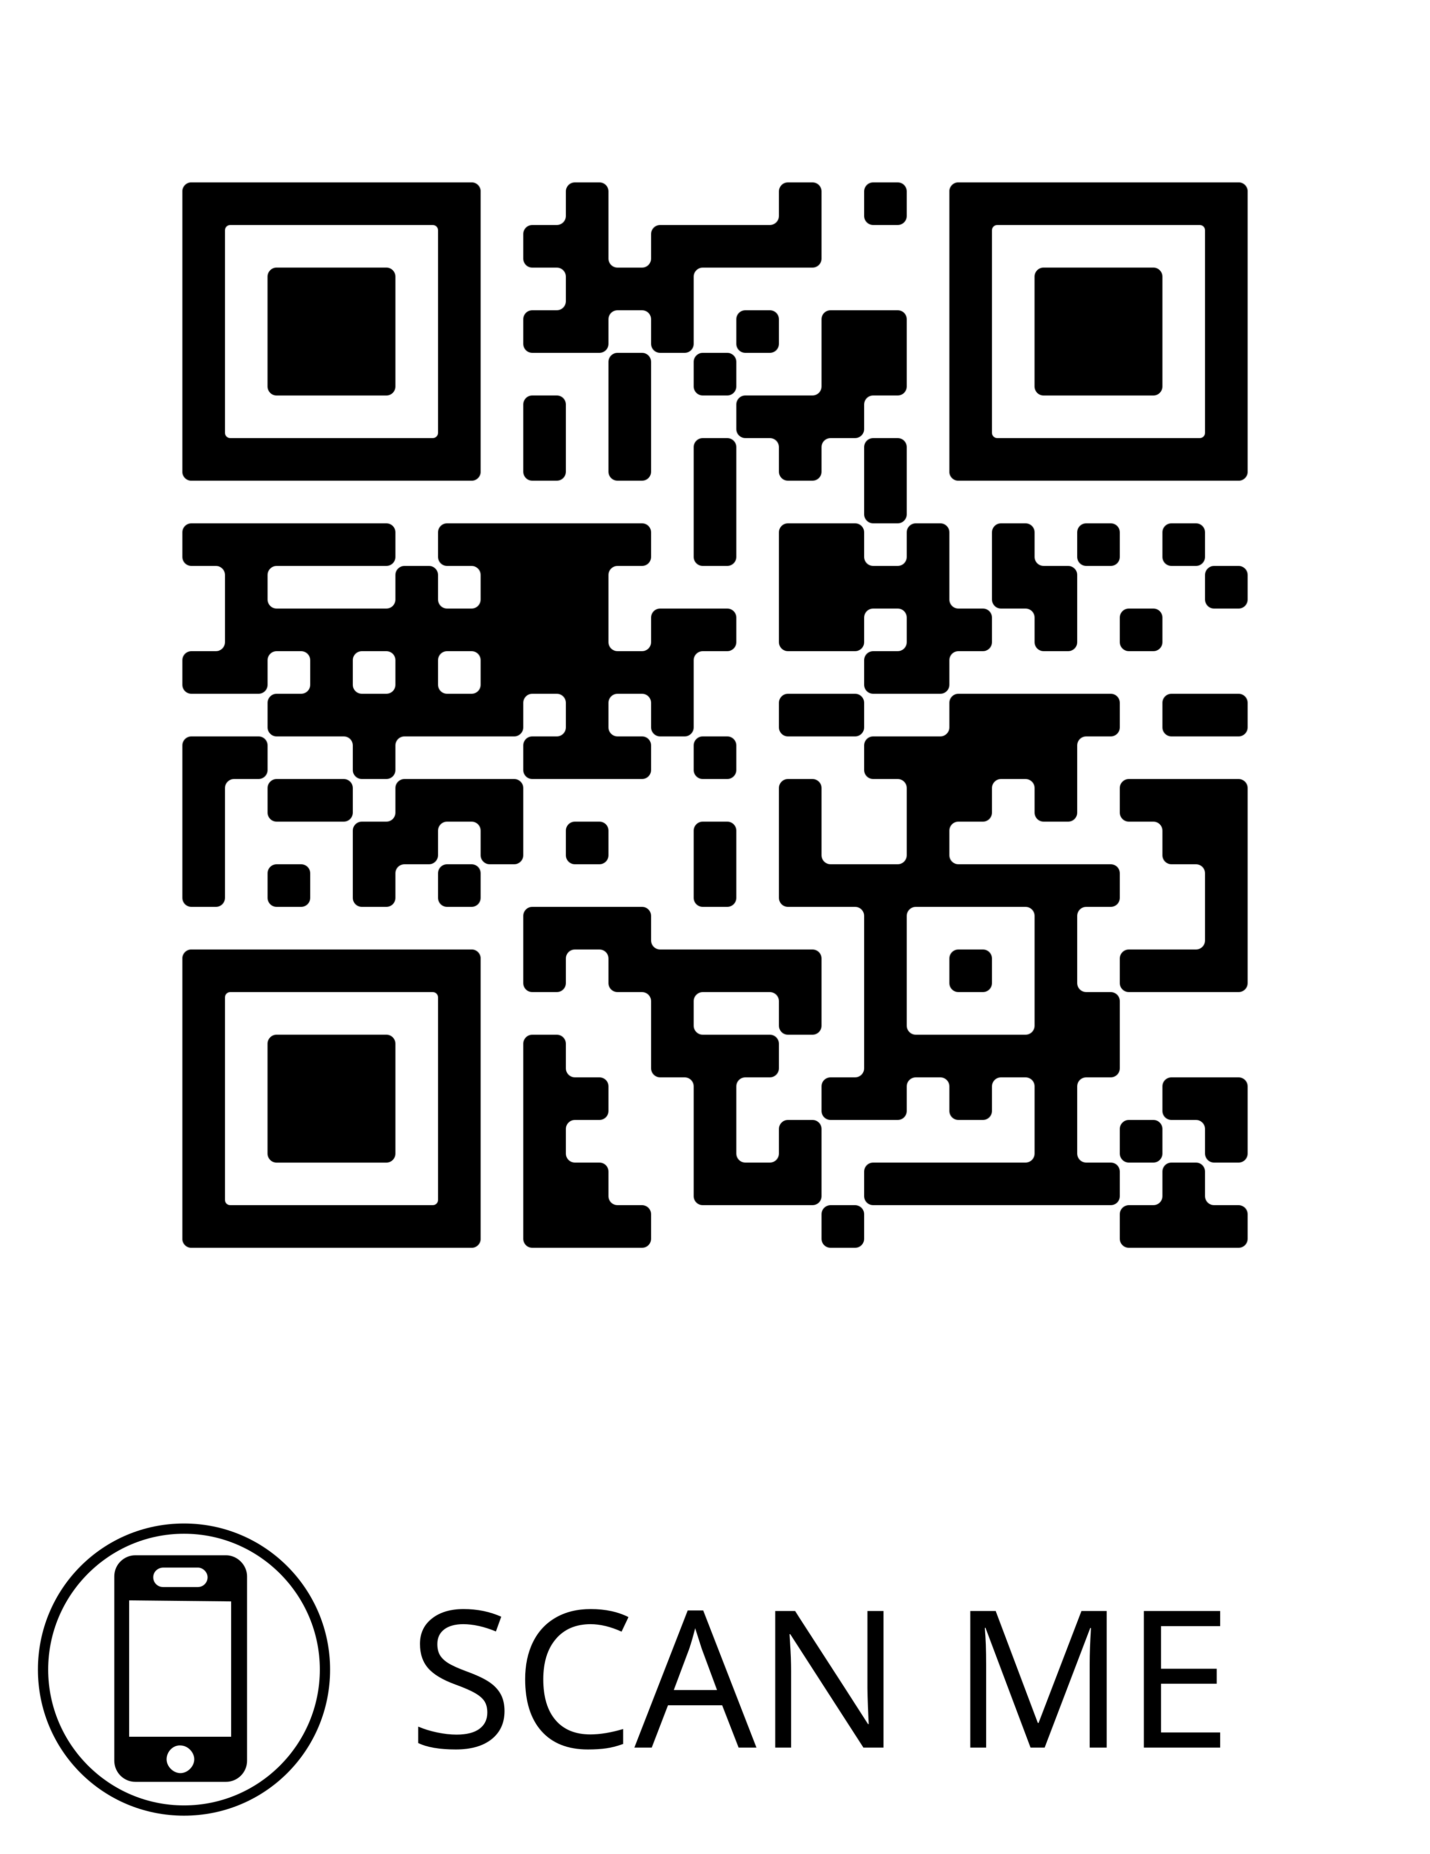

Contact Details of Speakers:
Paul Carnemolla
